Мат в 1 ход.

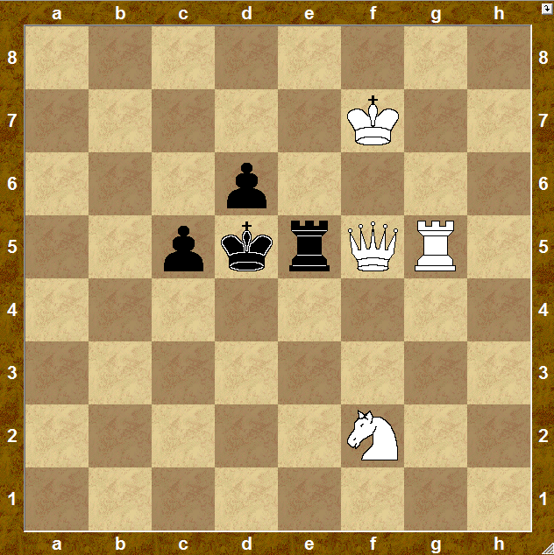

1. ____________

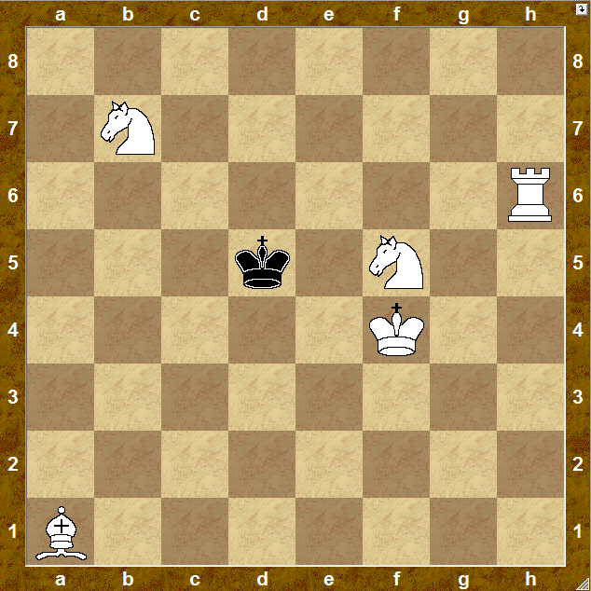

1. ____________

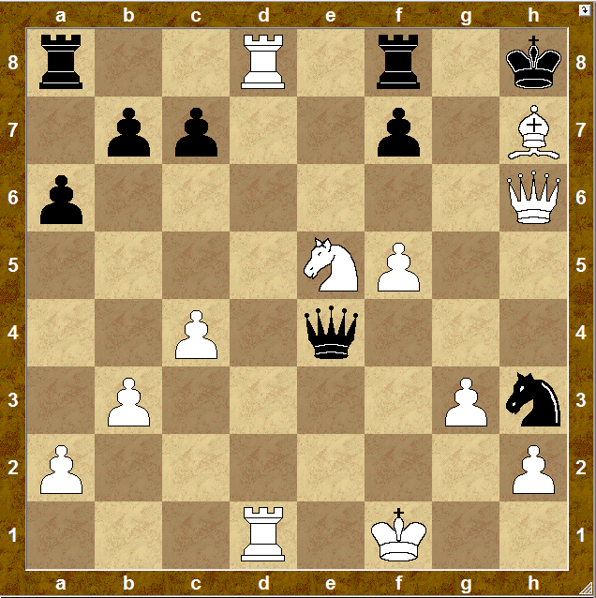

1. ____________

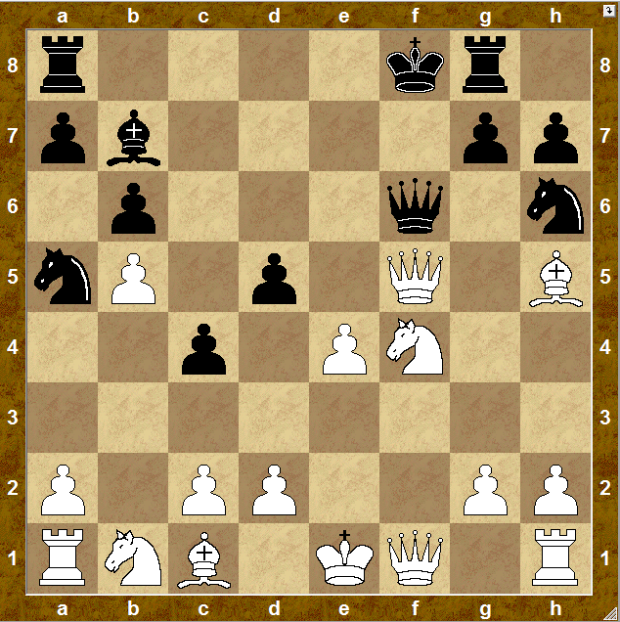

1. ____________

Мат в 1 ход.

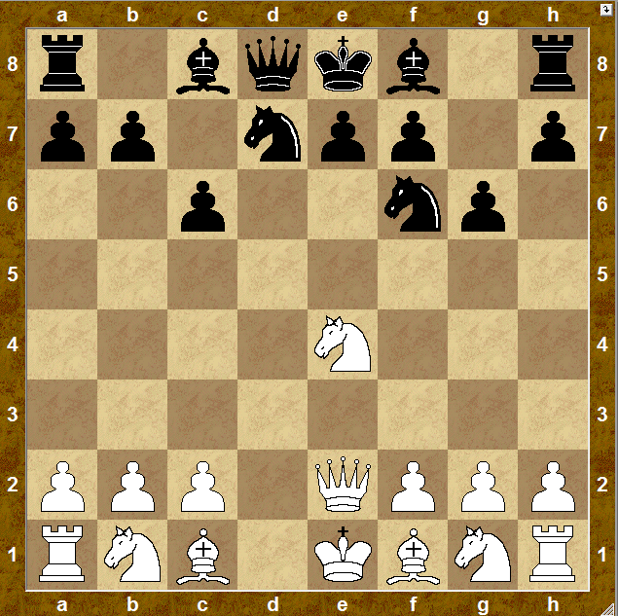

1. ____________

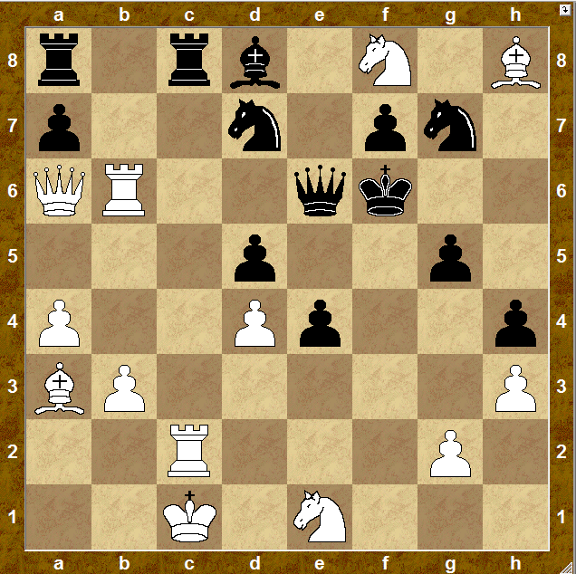

1. ____________

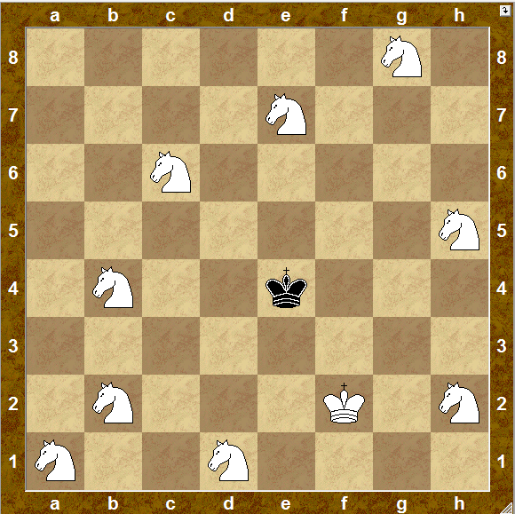

1. ____________

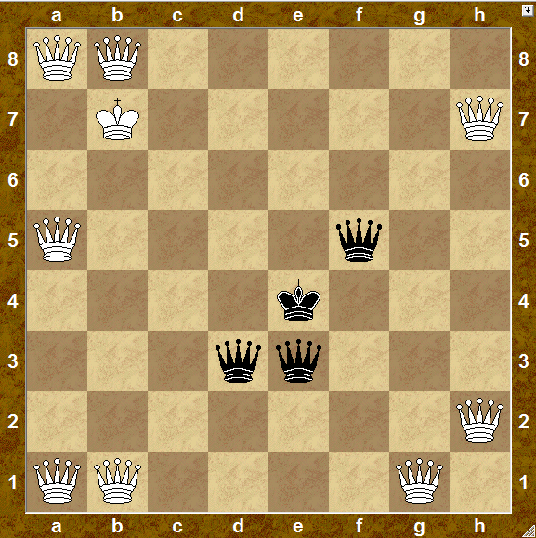

1. ____________

Мат в 2 хода.

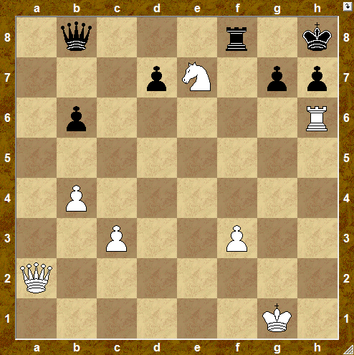

1. ____________ _____________

2. ____________

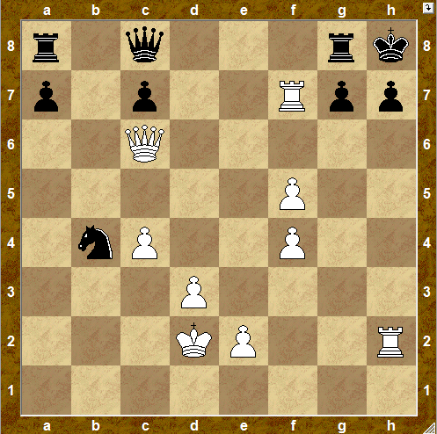

1. ____________ _____________

2. ____________

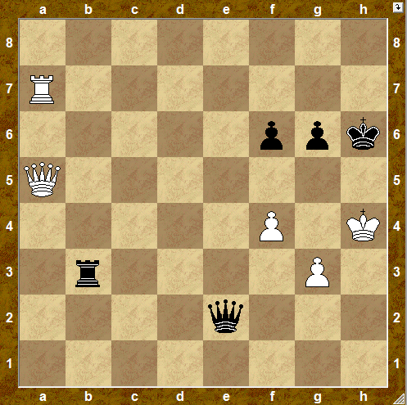

1. ____________ _____________

2. ____________

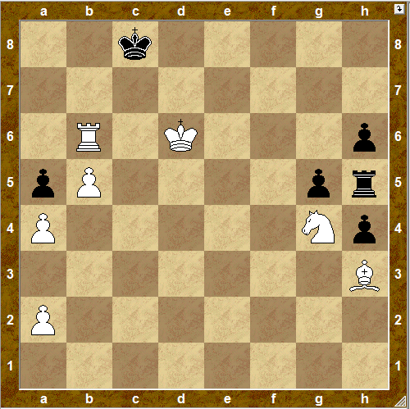

1. ____________ _____________

2. ____________

Мат в 2 хода.

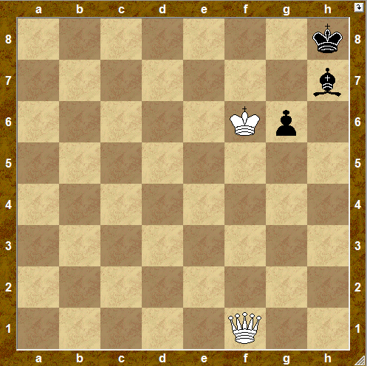

1. ____________ _____________

2. ____________

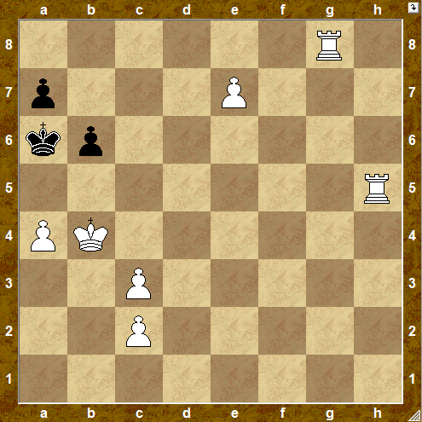

1. ____________ _____________

2. ____________

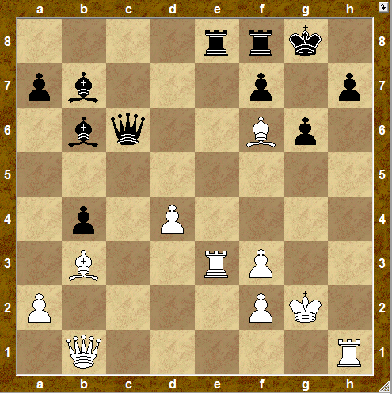

1. ____________ _____________

2. ____________

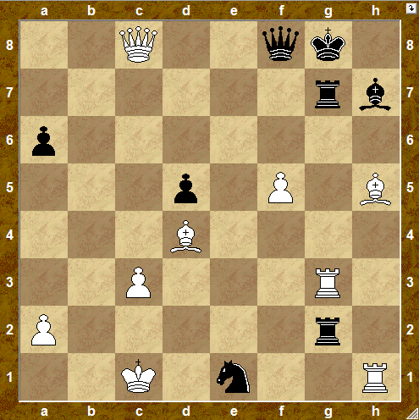

1. ____________ _____________

2. ____________

Мат в 2 хода.

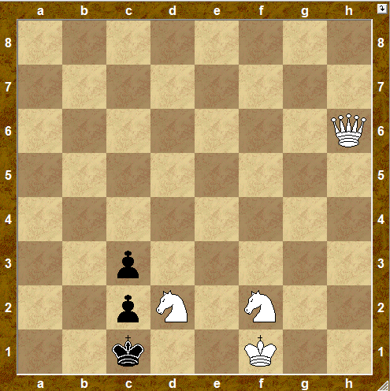

1. ____________ _____________

2. ____________

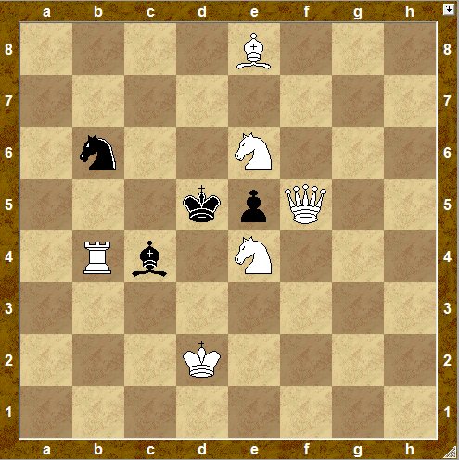

1. ____________ _____________

2. ____________

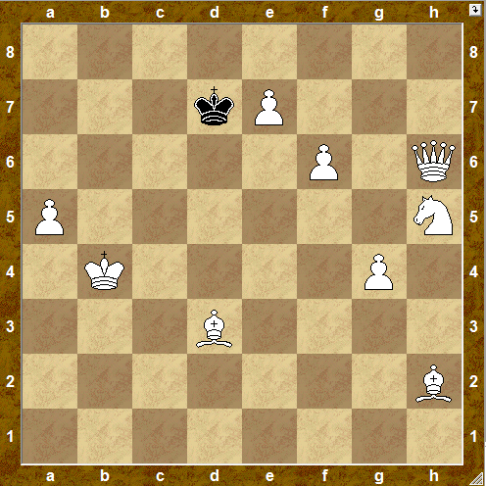

1. ____________ _____________

2. ____________

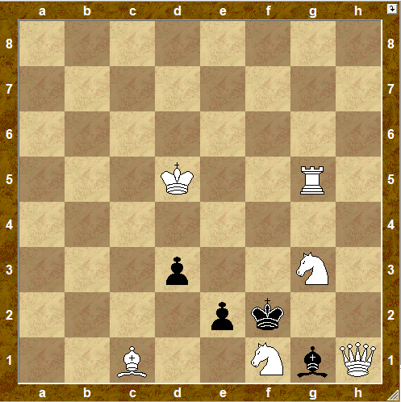

1. ____________ _____________

2. ____________

Мат в 2 хода.

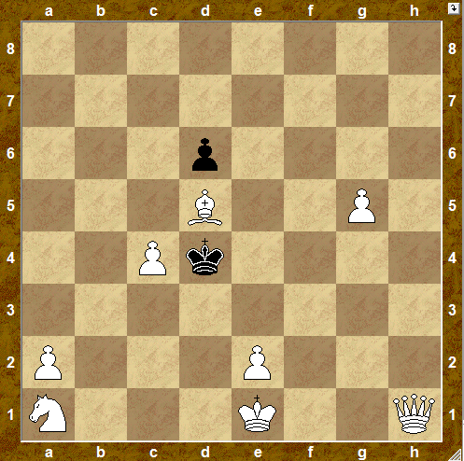

1. ____________ _____________

2. ____________

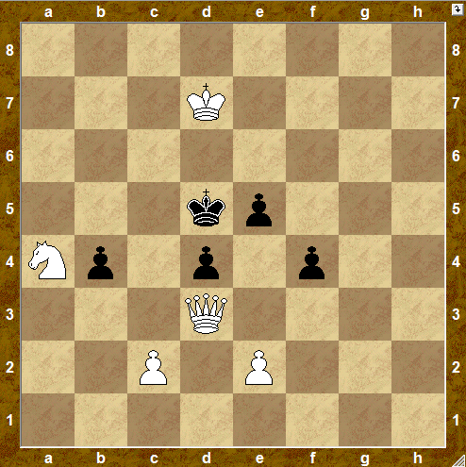

1. ____________ _____________

2. ____________

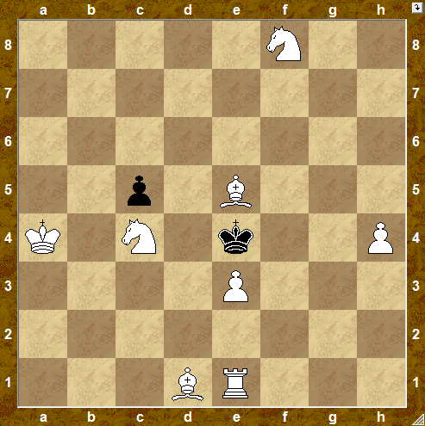

1. ____________ _____________

2. ____________

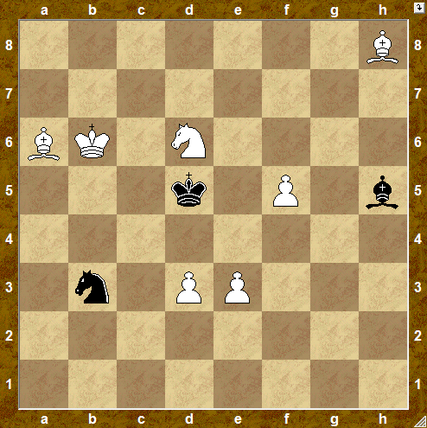

1. ____________ _____________

2. ____________

Мат в 2 хода.

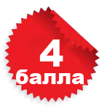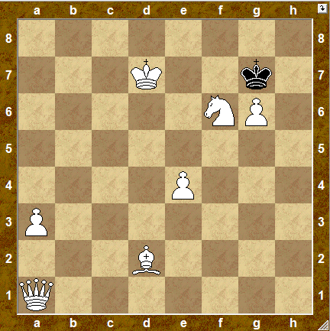

1. ____________ _____________

2. ____________

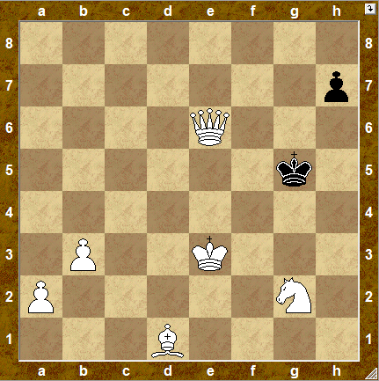

1. ____________ _____________

2. ____________

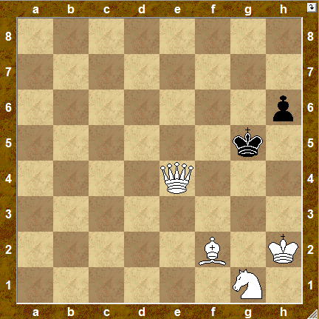

1. ____________ _____________

2. ____________

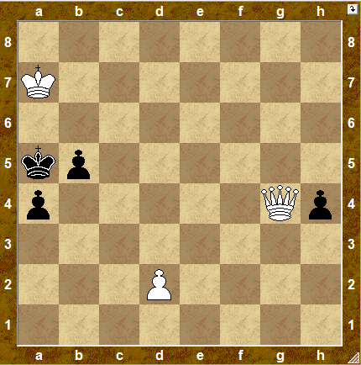

1. ____________ _____________

2. ____________