Мат в 1 ход.

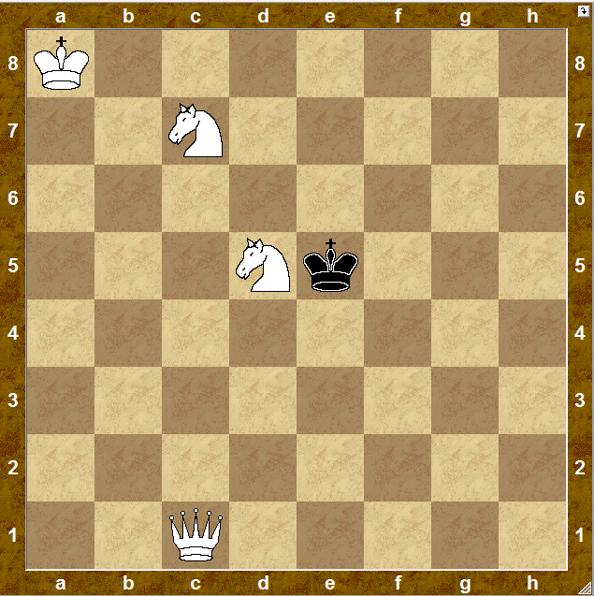

1. __________

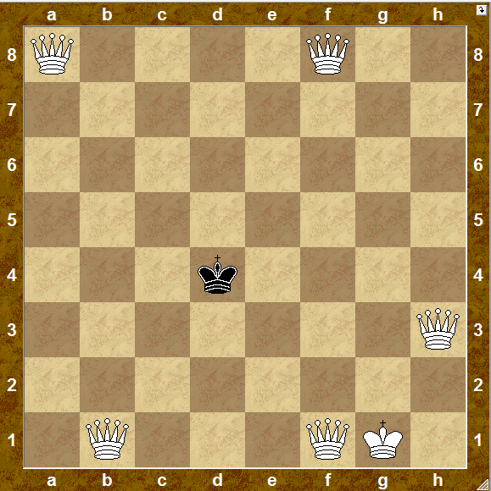

1. __________

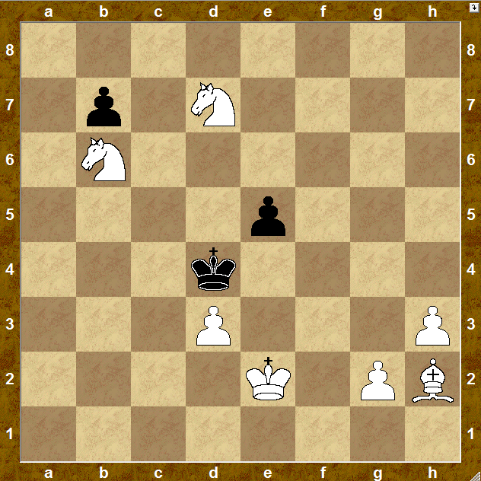

1. __________

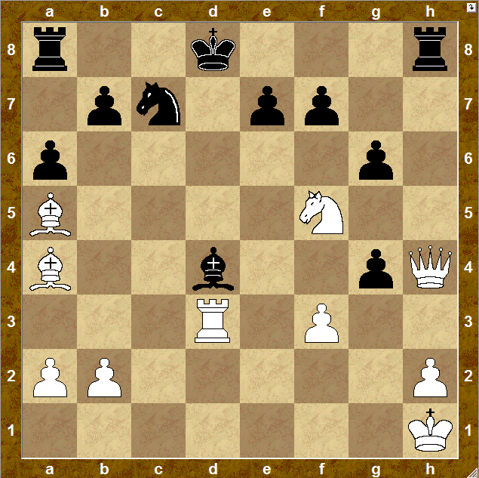

1. __________

Мат в 1 ход.

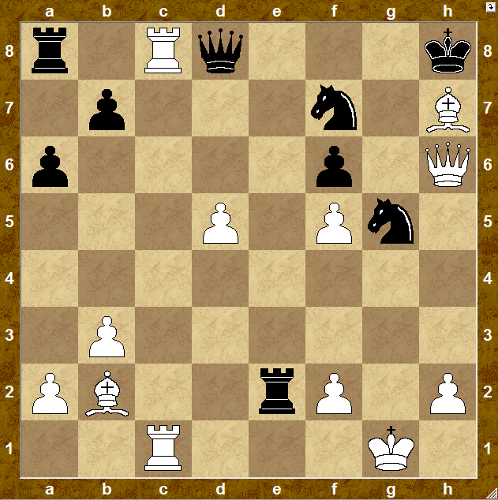

1. __________

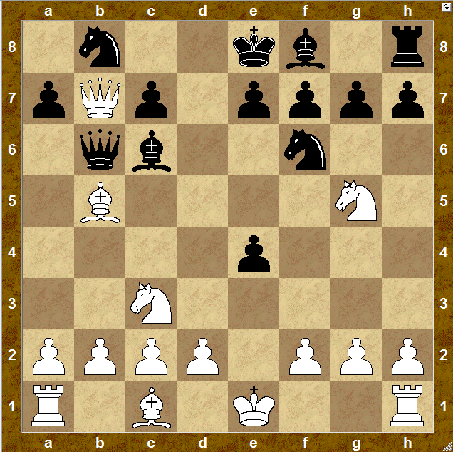

1. __________

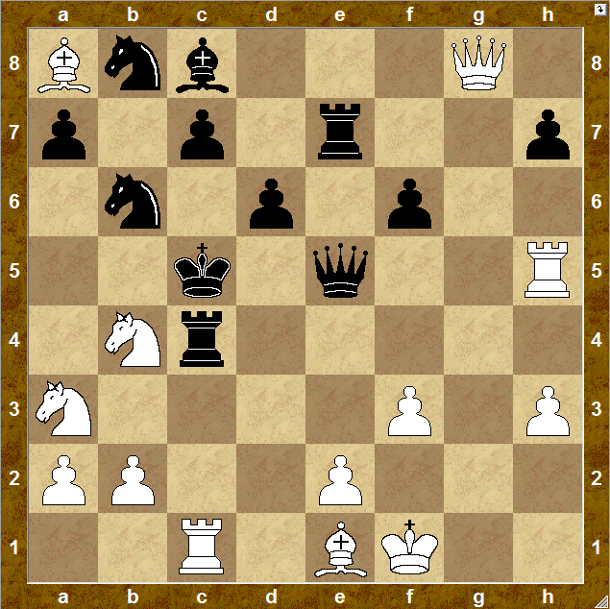

1. __________

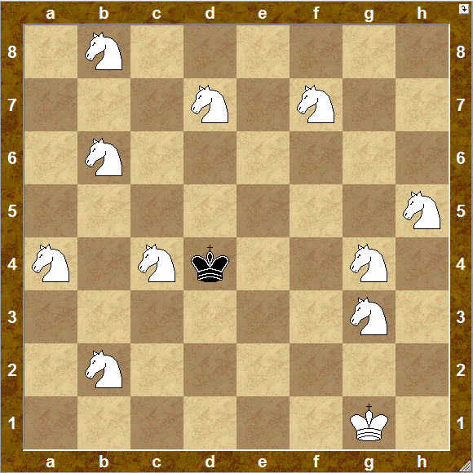

1. __________

Мат в 2 хода.

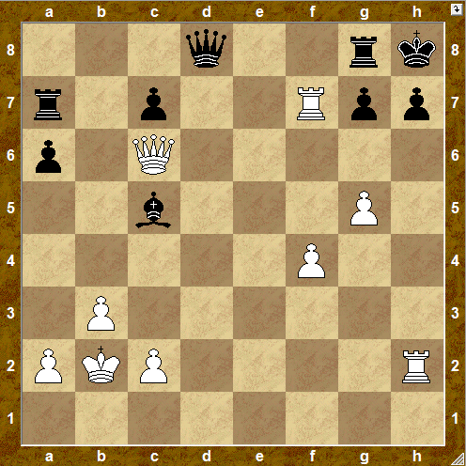

1. __________ ____________

2. __________

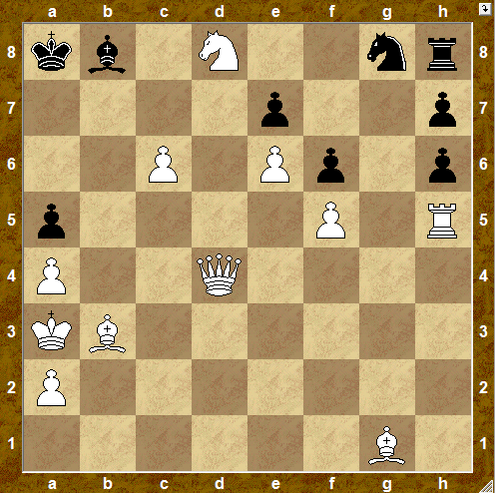

1. __________ ____________

2. __________

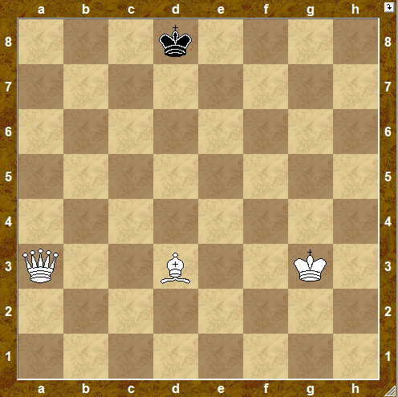

1. __________ ____________

2. __________

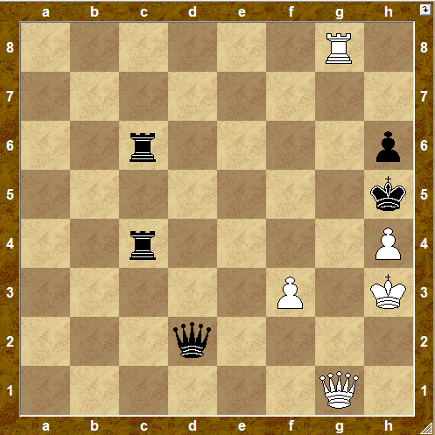

1. __________ ____________

2. __________

Мат в 2 хода.

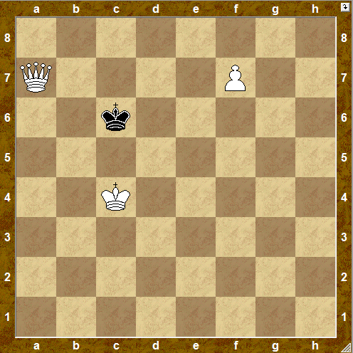

1. __________ ____________

2. __________

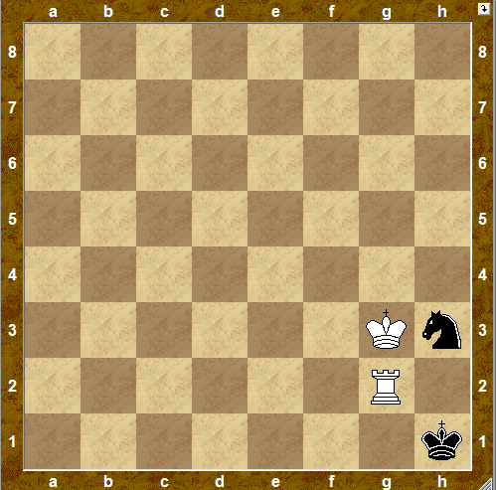

1. __________ ____________

2. __________

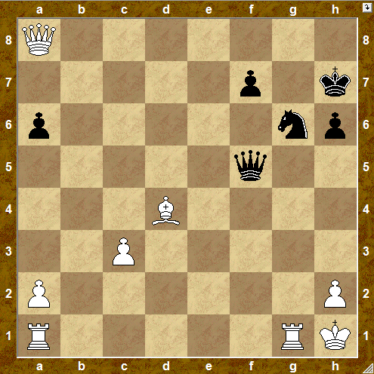

1. __________ ____________

2. __________

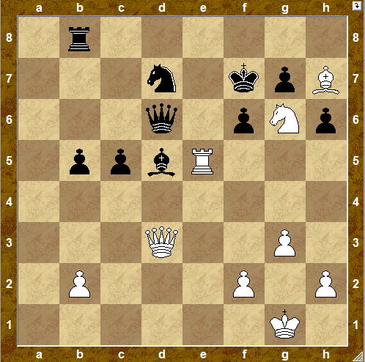

1. __________ ____________

2. __________

Мат в 2 хода.

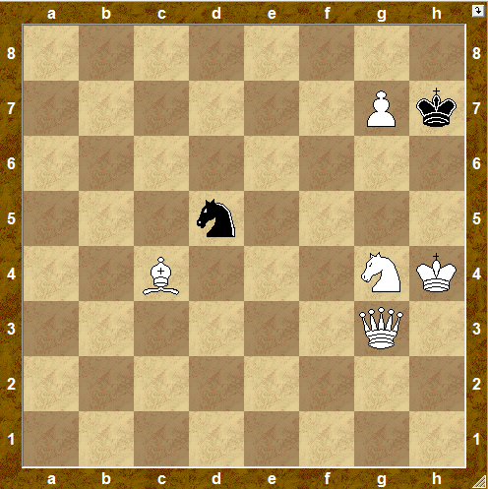

1. __________ ____________

2. __________

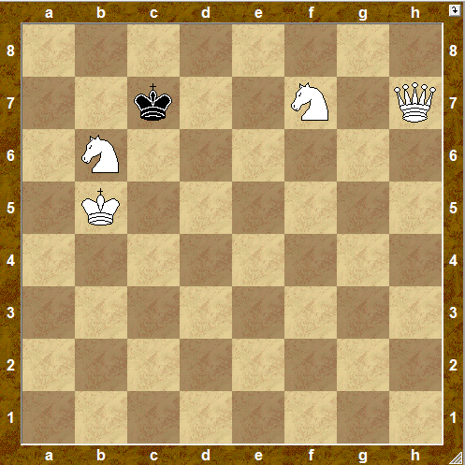

1. __________ ____________

2. __________

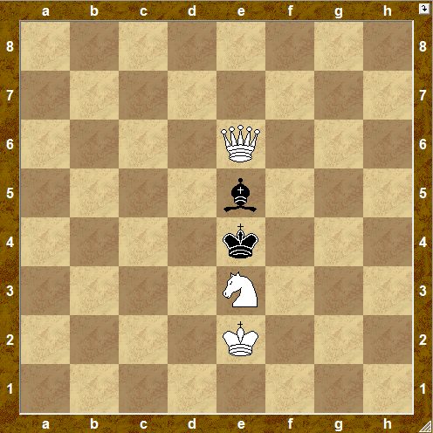

1. __________ ____________

2. __________

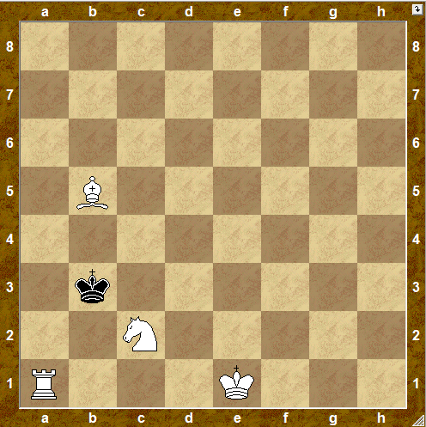

1. __________ ____________

2. __________

Мат в 2 хода.

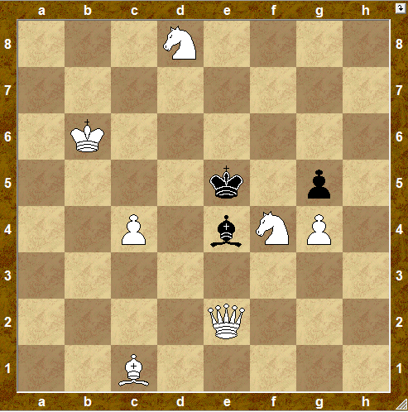

1. __________ ____________

2. __________

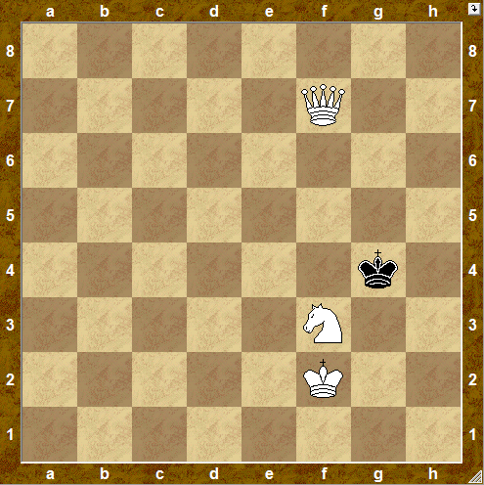

1. __________ ____________

2. __________

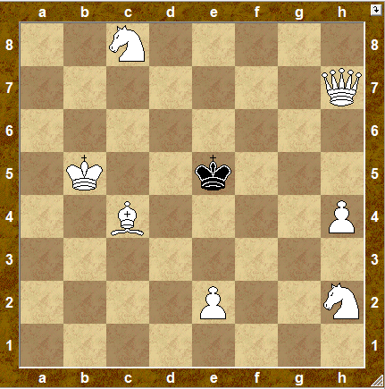

1. __________ ____________

2. __________

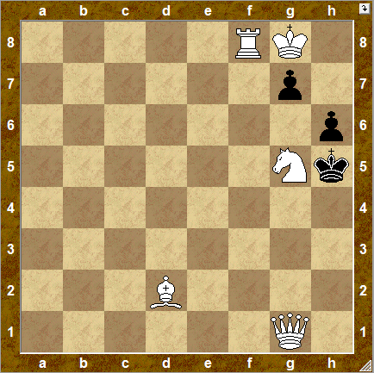

1. __________ ____________

2. __________

Мат в 2 хода.

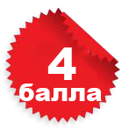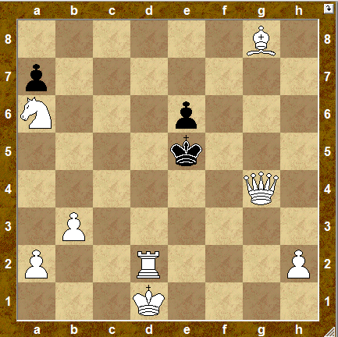

1. __________ ____________

2. __________

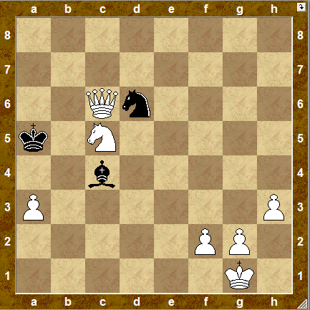

1. __________ ____________

2. __________

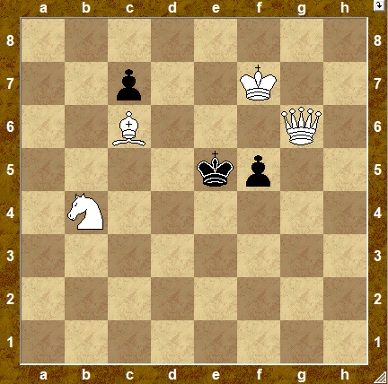

1. __________ ____________

2. __________

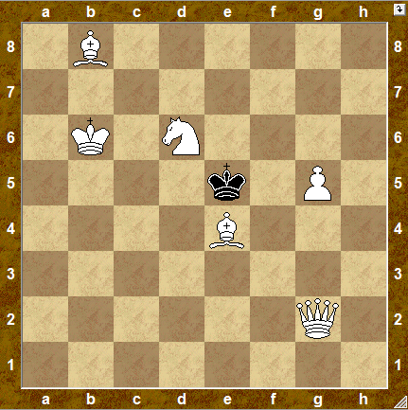

1. __________ ____________

2. __________